**VICE – created by TTERRAG**

**information highlighted grey for quick summarized read**

**The VICE (Visual Identification Conveyance Enhancement)** system is a proposed Conveyance monitoring solution designed to provide real-time information, alerts, analytics, and performance tracking for SMF1 Conveyance. This analysis evaluates the capabilities of the current VICE prototype and the insights gained from a test conducted on December 17th, 2024 in the CAP department of SMF1.

**System Overview**

* **Real-Time Monitoring**: Uses computer vision to detect various conveyor conditions, including jams, standdowns, full capacity, gridlock, and emergency stops.
* **Alert System**: Provides real-time notifications of detected issues via Slack integration and customizable thresholds.
* **Metrics and Analytics**: Tracks conveyor health scores, incident frequencies, and other key performance metrics.
* **Data Logging and Reporting:** Automatically generates reports, stores historical data, and enables data export.
* **Performance Monitoring**: Calculates uptime, efficiency, and mean time between failures to identify problematic areas.
* **User-friendly Interface:** Provides a GUI for monitoring multiple regions of interest, with real-time video feeds and interactive controls.

VICE is designed to provide more insight into what drives productivity. The tools we have now are incredible and are so valuable but our tools to identify AA mechanical barriers are archaic; trouble tickets and JLL hearsay are not reliable sources to determine our AAs barriers reliably. VICE provides a high-level approach to the largest mechanical component of SMF1. With the conveyance as our heart, we now have a stethoscope to not only see but understand our conveyance unlike before. Please read the information below to understand more of VICEs’ capabilities and reach.

**Test and Analysis**

Tests were conducted thoroughly on DEC 16th and DEC 17th. 12 hours each day the program collected data in a controlled fashion with tterrag monitoring for any disturbances. During this time across 41 regions of inspection over half a million detections were made and logged for data reconstruction. The data is summarized below.

1. **Conveyance Health Monitoring:**
   1. The "System Health Over Time" graph (See last page) shows the VICE-assigned conveyance health score for the examined area over a 2-hour period.
   2. The line of fit indicates an overall decreasing trend in conveyance health during the test period every 5 Minutes.
2. **Productivity Rate Correlation:**
   1. The "Productivity Rate" graph displays the pick rates for the same period, which are correlated with the conveyance health data.
   2. **The analysis shows a moderate to strong positive correlation between conveyance health and pick rate, with a Pearson correlation coefficient of 0.6889 and a p-value of 0.0401 (statistically significant).**
      1. This vital calculation proves that conveyance on the 17th was a reason capacity misses could be occurring…also providing flow with necessary insight to our conveyance load.
   3. This suggests that as conveyance health decreases, the pick rate also tends to decrease, and vice versa. We no longer need to assume these things…we can QUANTIFY THEM!!
   4. On average for each percentage of conveyance health lost there was a 1.12094 UPH drop in CAP. The cost impact cannot be understated.
3. **Calculation description**
   1. The calculation used weighted averages as well as color detection to calculate average conveyance health…each detected had a corresponding color and a corresponding weight that was used to calculate the conveyance health as a total metric.
   2. PLEASE SEE EXCEL SHEET FOR MORE INFO
4. **Limitations and Future Considerations:**
   1. The test was conducted on a small scale, and the observed correlations could potentially be influenced by randomness.
   2. To further validate the findings and the VICE system's capabilities, additional larger-scale tests and data collection would be necessary.
   3. Which is what I want to test more of and the reason for writing this is to find out what solutions I have to test this more.

**Recommendations**

Based on the analysis, the following recommendations are proposed:

1. Expand VICE Deployment: Consider using the VICE system across a broader range of facilities and departments to gather more comprehensive data and validate the observed relationships.
2. Enhance Data Collection and Analysis: Improve data collection methods, increase sample size, and explore more advanced statistical techniques to strengthen the correlation analysis and uncover additional insights.
3. Integrate VICE with Other Systems: Explore opportunities to integrate VICE with existing warehouse management, maintenance, and performance tracking systems to create a more comprehensive operational intelligence platform.
4. I would love your professional opinions on the best way to move forward. Whether this be continuing slowly while I work on this in my free time…escalating the code so that someone else can develop it, allowing me to develop it on company time, or scrapping it entirely.

Conclusion

The VICE system shows promising capabilities and to be completely honest I have been very impressed with the overall uses of VICE. From early SEV 1/2 detection to implementing machine learning I think this is a tool that could greatly enhance the AA experience without the AA ever knowing it. While also bolstering the power of operations and its ability to drive safety, AA experience, quality, productivity and cost. PLEASE reach out to me with any questions.  
  
  
EVALUATION

|  |  |  |
| --- | --- | --- |
| **ISSUE** | **ACTION** | **RESULT** |
| It takes jam clearers too long to get to, clear and radio coorespondance. Reducing efficiency. | Implemented an automated Slack channel workflow integrated with VICO for real-time jam detection and instant notification to relevant personnel. | On average through 20+ days of testing the slack channel is 32 seconds faster than humans. Increasing efficiency and decreasing radio chatter and human error. |
| We have no metric to track our conveyance over time. When we speak about conveyance the only paper trail is trouble tickets which do not tell the whole story | Developed and implemented a robust Conveyance Health Metric using VICO technology. This metric synthesizes real-time data from multiple sources to provide a holistic, quantifiable representation of the entire building's conveyance system performance. | Provides insight to leadership. Invaluable insight that can be used to make smarter decisions and learn data driven lessons over time.   * Calculates UPH loss over time (CAP) as well as standard error and overall conveyance health |
| Not every individual has access to VIZ and the vital data on VIZ | Created metric and slack to allow coachings and information to be disseminated faster and with data to provide extra reason. | Led to better AA engagements when engaging about stand down and other conveyance informations. Additionally helped greatly reduce the learning curve for new Jam clearers |
| There is no way other than human inspection and human input to track the conveyance in a way that can identify where preventative maintenece could be needed or employed | Created a machine learnig driven device to detect areas and places where mainenence could be needed, each tailored to a location | CAP was able to identify 3 ARSAW stations that needed maintenece before they became large scale operations that would shut the station down for days, this reduced AA frustrations and led to a easier experience for all. |

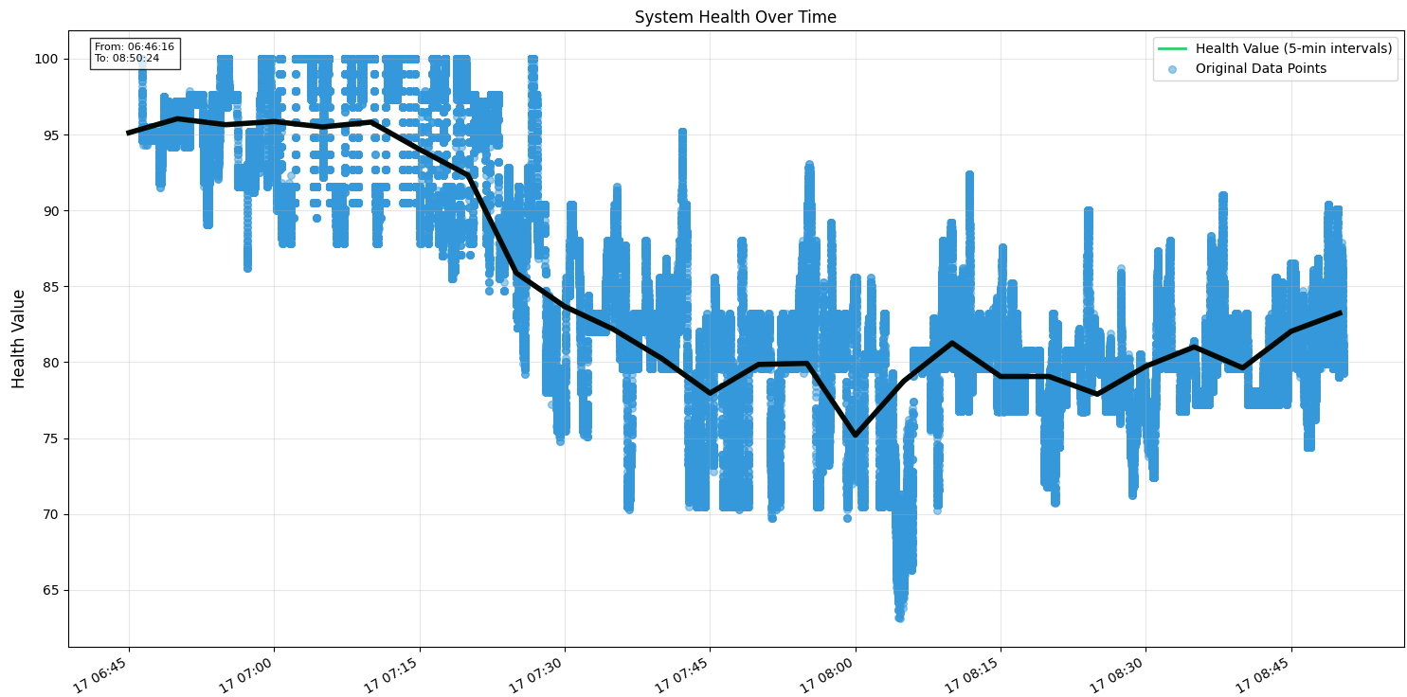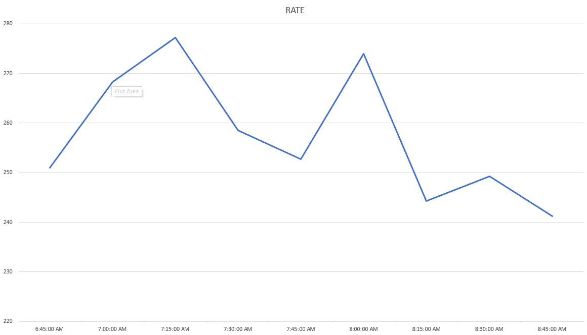

These graphs represent the conveyance health (top) and the corresponding pick rate (Bottom) the correlation calculated above can be visualized below.